**Individual project**

**Machine Learning to Detect**

**Spam Emails**

Name: Leon Jones

Student ID: 18048528

First Supervisor: Shaily Jane

Second Supervisor: Mabrouka Abuhmida

# Statement of Originality

This is to certify that, except where specific reference is made, the work described within this project is the result of the investigation carried out by myself, and that neither this project, nor any part of it, has been submitted in candidature for any other award other than this being presently studied.

Any material taken from published texts or computerized sources have been fully referenced, and I fully realize the consequences of plagiarizing any of these sources.

Leon Jones

Student Name (Printed) ………………………………………….

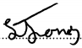

Student Signature - ………………………………………….

Computer Science

Registered Course of Study ………………………………………….

30/04/2021

Date of Signing ………………………………………….

# Abstract

Spam email classification is a traditional problem in Nature Language Process (NLP). This dissertation will be looking at a Naïve Baye approach to tackling the growing problem of spam emails. Within this dissertation there will be utilization of various segmentation methods based on scikit-learn and nltk to create a classification model. Numerous pre-processing methods are used including Term Frequency-Inverse Document Frequency (TF-IDF) and bag of words to improve the predictive power of Naïve bayes classification. The dissertation is split into two prototypes the first showing the development and training of the machine learning model that includes testing showing the accuracy of the model from test data. The final prototype is the implementation of the ML model into a web framework allowing a visual representation of the model and ability to be tested and gain user feedback. Ultimately showing the feasibility of using Naïve Bayes for email classification.

Table of Contents

1.0. Introduction and Problem Statement 5

1.1. Aim 6

1.2. Objectives 6

2.0. Background Research 7

2.1. Spam Email Detection 7

2.2. Filtering Techniques 8

2.3. Machine Learning Algorithms 9

2.3.1. Naïve Bayes Classifier 9

2.3.2. Decision Tree 10

2.3.3. Clustering 11

2.3.4. Support Vector Machines 12

2.3.5. Artificial Neural Network 12

2.4. Conclusion 13

3.0. Methodology 13

3.1. Introduction 13

3.2. Agile Software Development 14

3.3. Project Control 14

3.4. Language and Libraries 15

4.0. 1st Prototype 16

4.1. Design 16

4.2. Implementation 17

4.2.1. Dataset 17

4.2.2. Data Analysis and Visualization 19

4.2.3. Text Preprocessing 20

4.2.4. Vectorization 21

4.2.5. Training Model 23

4.2.6. Data Pipeline 24

4.2.7. 1st Prototype Testing 25

4.3. 1st Prototype Evaluation 26

5.0. Final Prototype 27

5.1. Design 27

5.2. Implementation 27

5.2.1. Django Web Framework 27

5.2.2. Designing Web Interface 28

5.2.3. Linking ML Model 31

6.0. Testing 35

6.1. Testing Plan 38

6.2. User Feedback 39

7.0. Objectives Review 42

8.0. Conclusion and Future Appraisal 43

9.0. References 46

10.0. Table of Figures 48

11.0. Table of Equations 49

12.0. Appendix 50

12.1. Minute Meetings 50

12.2. Additional Evidence 51

# 1.0. Introduction and Problem Statement

As a result of the internet gaining popularity during the 1990’s advertises realized that they could advertise via email to thousands of people at low cost with a click of a button. The process of sending unwanted commercial bulk emails is known as spam. This soon become one of the biggest issues within the world of internet with users receiving hundreds of unwanted spam emails daily.

As users grew tired of this, they started to find way to avoid spam flooding their inbox. They came up with the idea of if they could predict that an email was spam before reading it then this would save them time manually filtering though the emails. There are now programs called spam filters that do this process to inform the user if an email is worth reading.

Spam consists of spammers sending an email to millions of emails addresses intending for a small amount of interaction or responses. The percentage of spam emails being sent is increasing at a rapid rate and accounts for 77.2% of all the worlds email traffic. Spam as well as being very irritating to users it can also have very detrimental effects for both individual users and businesses as it can cause problems such as such as cost shifting, fraud, resource wastage, and the displacement of legitimate mail (Insu Park, 2016).

A report carried out by Kaspersky in 2012 found that over 2.8 percent of all emails contained malicious files. With the most common email attacks being Identity theft, Phishing Attacks, Viruses, and spam, with them all having serious consequences to their targets (Namestnikova, 2012). Therefore, it is important to filter out as many of these emails as possible to maintain user safety.

Spam filters work by assigning scores to emails based of certain criteria such as the contents of the email, this can be broken down to scoring individual words within an email based on the number of times a word may appear within spam or ham mail. The scoring of words can differ within spam filters as its due to the dataset and methods used within the training process of the machine learning model (ELseuof, 2011).

Spam filters are not 100% accurate and due to spammer constantly finding ways around the current filters. The continuous development of these filters is important to help narrow the amount of spam that is received in users’ inboxes and to stay a step ahead of spammers.

# 1.1. Aim

The aim of this project is to research and gain understanding on the detection of spam email by using ML algorithms and to develop a spam filtering algorithm using modern techniques and tools.

# 1.2. Objectives

The objectives for the project are –

* Research the reason why we need spam email detection, and the impact spam is having on both individual users and businesses.
* Research and explore spam filtering tools that are available and gain an understanding on the ML algorithms used to detect spam emails.
* Research the different languages used to detect spam emails and gain understanding on the security aspects.
* Use the research to identify the optimal tools and algorithms, implement them to create a spam emails detection classifier that should accurately predict spam emails.
* Improve spam email detection classifier and develop a web application to allow testing of the developed spam filter.
* Test the spam email detection classifier to ensure that it is accurately detecting spam emails.

# 2.0. Background Research

## 2.1. Spam Email Detection

Before we can investigate spam email detection, we need to understand spam. An accurate definition of spam is the abuse of electronic messaging systems to send unsolicited messages in bulk indiscriminately (Hayati, 2010).

Spam email detection is the process of detecting unwanted and malicious junk email (spam) to prevent it getting into the users email inbox. This is done for both ingoing and outgoing emails via the ISPs by using a variety of different filtering techniques and algorithms. Spam email detection is extremely important in today’s world with it estimated that over 77.2% of all emails are considered as spam (Society, 2015). This highlights why the continuous development and updates to spam filters are needed to keep up the creative way’s spammer are continuously developing to get around current filters.

Although spam email detection is not 100% accurate its extremely important as it filters most of the spam emails, stopping it getting through to the user’s inbox, saving the user time and having to go through each email one by one. Spam emails often contain malicious content that put the user’s system at risk of viruses, advance fee fraud and phishing attacks with the offend goal of spam email being to obtain bank details or personal information.

Phishing is a highly popular way scammers use to obtain this data and the Federal trade commission estimated that over $57 million is lost every year to phishing schemes. A phishing scheme is an email that look like they are from the company that you trust such as an online store or a bank, they will then prompt to enter personal information that they can then use to profit from.

Phishing attacks work one of three ways. They will try to trick you into these by offering some sort of cash back or fake invoice to encourage the user to enter the data required to access personal or business accounts, they Infect your computer with malicious links found in the email with a goal to infect your computer or contain a scam in which the scammer will attempt to defraud you, these schemes are both detrimental to the user and company (Mohamed, 2014).

The advance fee fraud which is a scam where they will ask for an upfront fee promising a larger amount of money later, this scam causes a high risk of financial loss and high risk to your personal data. As well as causing potential damage to the user’s computer spam email fills up email inboxes and can result in servers becoming overloaded. To scammers spam emails are a very lucrative and cost-effective method used even with the very low response rate of one in ten thousand and with so many companies offering to send bulk emails at an extremely low cost its very appealing (Thomas J. Holt, 2007).

## 2.2. Filtering Techniques

The are many different spam filtering techniques available to filter and identify spam emails offering different way to detect spam. Here are some of the approaches to spam filtering techniques.

* **Content Based Filtering Technique** – The content-based filtering technique approach is used to create automatic filtering rules and to detected spam emails using machine learning. This technique uses Naive Bayes, support vector machines and neutral networks and its analysis the words and phrases within the emails to generate the spam filtering rules. (Ajibuwae, 2019)
* **Case Base Spam Filtering** – The case base spam works by firstly collecting the users emails both spam and non-spam emails using a collection model. The information is then evaluated and classified using two vector sets and an machine learning algorithm is used to update data sets and to find if incoming emails are spam or not spam (Sharma, 2018).
* **Rule Based Spam Filtering Technique** – The rule-based spam filtering technique has set rules and access to many patterns that are typical within spam emails. Each pattern is assigned a set score and if multiple patterns are used then the score increases and If the patterns are not recognized then the score is deducted. This technique requires a large amount of updating as the spammers find effective ways around the filter patterns (Shrivastava, 2007).
* **Previous Likeness Based Spam Filtering Technique** – The previous likeness filtering technique uses machine learning and a memory base of emails to compare to incoming emails and checks the similarity. This technique uses the k-nearest neighbor approach and plots attributes of the emails in a multi-dimensional space vector and all new instances are plotted as points.
* **Adaptive Spam Filtering Technique** – The adaptive filtering technique collects emails in different classes and each class has emblematic text. All new incoming emails are the check against the classes for a percentage of similarity, once the similarity is then calculated the email is then placed into the appropriate class. As the more information is gathered the classes become more reliable and new techniques that spammers may be using can be easily identified.

## 2.3. Machine Learning Algorithms

Machine learning is a type of artificial intelligence that allows computers to learn from sets of example data and improve their accuracy over time without being programmed. Algorithms are trained to look for patterns and make prediction based of these patterns enabling the computer to preform specific tasks intelligently (The Royal Society, 2017).

There are many different spam detection algorithms that all use different machine learning techniques to detect spam. The main ML algorithms used withing spam detection are Naive Bayes, Decision trees, clustering, and Support Vector Machines. All these algorithms are used to detect spam, and all offer different solution to the problem of detecting spam.

### 2.3.1. Naïve Bayes Classifier

The Naïve bayes algorithm is a probabilistic classifier that works out the probability by counting the frequency and combination of values in each dataset (Patil, 2013). Naïve bayes uses the Bayes theorem of probability to find out the probability that an incoming email is spam by using the words in the email. This is done as certain words have a probability of being contained in spam emails, this is found by training the filter to indicate spam emails though methods like bag of words to learn typical words that are found in spam emails and learn words with a low probability of being in a spam email such as family names. Once trained the probability for each word is used to compute a new emails probability of being spam by using bayes theorem formula (Wei, 2018).

***P(spam)P(word|spam)***

***P(spam | word)*** = -------------------------------------------------------------------------------------

***P(spam)P(word|spam) + P(non – spam)P(word|non – spam)***

Equation . Bayes Theorem

Within the bayes theorem formula:

* P(spam | word) is the probability that a word within the email is spam.
* P(spam) is probability that the email is spam.
* P(word|spam) is the probability that a word appears in spam emails.
* P(non – spam) is the probability that a word is not spam.
* P(word|non – spam) is the probability that a word appears in non-spam emails.

Using this the overall probability of an email being spam is calculated by using the words contained within the email, if the email probability is calculated and indicates that the email is spam the email will then be flag as spam for the user (Rusland, 2017).

As Naïve Bayes requires training data the bigger the training dataset and the more emails that are run though the algorithm the more accurate it will become as it will have more information of the probability of words appearing within a spam email. The Naïve Bayes classifier commonly used with spam filtering software as it is relatively simple to incorporate and is extremely efficient.

### 2.3.2. Decision Tree

The decision tree classifier is a machine learning algorithm that follows a tree like structure and is used a lot as a spam filtering technique as it is easy to implement and understand. The decision tree is used to create a model that can decide the value of the sample based on attributes from existing data. Each decision tree node can either be a leaf node that gives a value to a class or it is a decision node which prompts tests to find the value of the class with a branch and sub tree representing all possible results of the test. The decision tree works by starting at the root of the tree and finding a leaf node that give the result (Kiamarzpour, 2013).

There are many diverse types of decision trees one being the NBTree Classifier this is a combination of naïve bayes and decision tree that is used to build a model that provides the probabilities of outcomes. The model works by using the naïve bayes classifies at the nodes and the decision tree develops a variable that is divided at each node (A Al-Allak, 2010). The NBTree classifier is useful in large databases or if the attributes are not independent of each other.

There is also an C4.5/J48 decision tree algorithm this generates a decision tree based of set training data. Each node of the algorithm chooses an attuite and can split itself into subsets and the leaf nodes of the tree represent a decision. The C4.5 is based on ID3 algorithm and tries to produce small and simple decision trees based on the premises that all cases are of the same class, the tree is a leaf and so the leaf is returned labelled with this class. For each attribute, calculate the potential information provided by a test on the attribute and calculate the gain in information that would result from a test on the attribute (on the probabilities of each case having a particular value for the attribute) (Sarit Chakraborty, 2012).

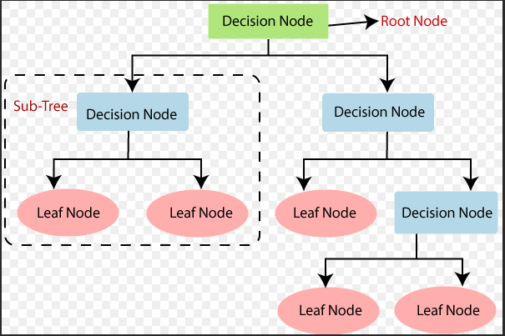

Figure 1. Decision Tree Example (JavaTpoint, 2020)

### 2.3.3. Clustering

The clustering method is a way to divide a group of objects into similar groups of objects known as clusters (a group of patterns). Clustering algorithms works by classifying objects to groups of a similar manners than the other groups. There are 2 different methods of clustering that are used for spam email detection density-based clustering and K-nearest neighbours (k – nn).

The K -nn algorithm is a simple machine learning algorithm that works as an object is classified by the majority vote of its neighbours and the object being assigned to a class most common to its nearest neighbour “k” (k is a positive integer). An example of K -nn is shown below if x has a k = 3 then find a class red or purple as there are two votes for red, red is the nearest neighbour of x (S.Ananthi, 2009).

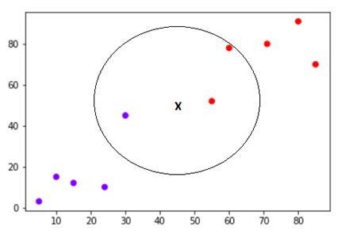

Figure 2. Nearest Neighbour Model

Density-based clustering is an unsupervised learning method that looks for concentrated area of points in data and where they separate by empty area. The points that are not part of the cluster are labeled as noise or outliers. There are three different tools provided to find the clusters. Defined distance, this uses a set distance to separate clusters from noise. Self-adjusting, this uses a range of distances to identify clusters from noise and lastly multi scale, this uses the distance from neighboring features to identify clusters from noise (Kriegel, 2011).

### 2.3.4. Support Vector Machines

The support vector machines are a supervised machine learning algorithm that is used for classification and regression. The support vector machines algorithm finds a hyperplane that is used to divide a dataset into two classifications spam and non-spam. A hyperplane is a linear line that separates and provides the classification of a data set. The margin is the distance between the hyperplane and the nearest point from each class sets and greater the margin between a data set the higher the chance of data being correctly classified (Gunn, 1998). This algorithm is accurate and very efficient for smaller data sets.

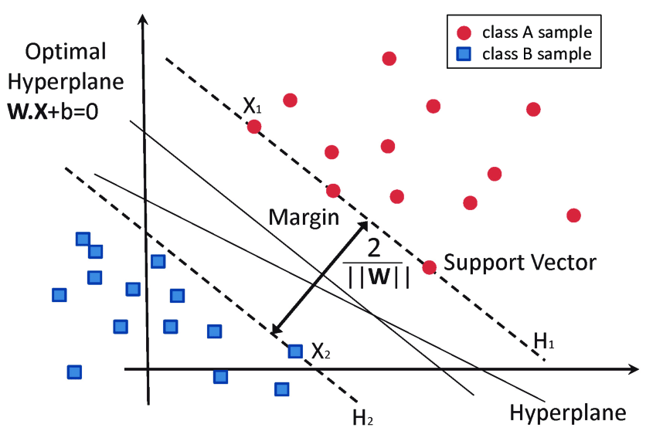

Figure 3. Classification of data by support vector machine (García-Gonzalo, 2016)

### 2.3.5. Artificial Neural Network

An Artificial Neural Network is a machine learning algorithm that are design to mimic the way that a human’s brain works to recognize relationships between sets of data. They interpret data recognizing numerical patterns contained in vectors. Within a neural network there are layers of interconnected nodes. These nodes all represent a perceptron this then feeds the signals made by multiple linear regression to functions. There are two main types of layers, input layers that collect inputs and output layers that output the signals (Berndt Müller, 1995).

Within spam email detection there are two main ANN algorithms are used Single Layer Perceptron (SLP) and Multi Later Perceptron (MLP). First the words are identified and are each giving mutual information score by using an algorithm shown below –

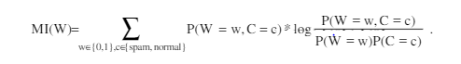

Equation . ANN Algorithm

Where C denotes the class (Spam or ham), P (W = w, C = c) equal to the probability of the word W occurring with W = 1 or is it does not W = 0 and P (C = c) the probability of an email being spam or ham. The probabilities are calculated using data obtained within the training dataset (FilterLevent Özgür, 2004).

## 2.4. Conclusion

The research above show that spam emails have become a very significant problem since the 1990s and they are not only flooding people’s inboxes with advertisements that take time to clear but containing malicious files that could cause danger for people’s security. This indicates that there is a need for the continual development of spam email detection filters to limit the risk and amount of spam users are receiving within their inbox.

From the research the efficiency and prediction power of the classification model is highly dependent on the training dataset. As the dataset is the basis of what the prediction will be made from, so it is important that an appropriate dataset is selected when training the model.

All the algorithms are a valid choice to use for spam email classification. This dissertation will be using the Naïve Bayes classification approach as it can be easily trained and implement on a user-by-user basis and can be tailored to the user’s emails to detect spam. Naïve Bayes is an efficient model for spam classification as it does not require a large amount of data to produce a sufficient model and as it is a generative model it can make prediction by altering the decision rules. Naïve bayes also makes probabilistic prediction which is very useful when for a spam email detection system.

# 3.0. Methodology

## 3.1. Introduction

This project will be using a naïve bayes approach to spam email filtering and this section will be discussing the entire project, that will be split into two parts prototype 1 and final prototype. The project will also show the approaches used for workflow, maintaining good coding standards and project control. Prototype 1 will demonstrate to approaches used creating the machine learning spam detection model that can accurately detect spam emails. The model will be trained using a dataset of spam and ham emails, the training process with consist of data analysis and visualization, text processing, vectorization, model training, training test split and creating a data pipeline.

The Final prototype will consist of the Naïve Bayes classification model trained within the first prototype being integrated into a web framework. The Django web framework is the framework that will be used within this project as it offers great functionality with machine leaning. This process with consist of pickling the model, designing the web Interface, creation of the Django project and linking ML model with the framework.

## 3.2. Agile Software Development

An agile software development approach was used within the development of the ML Spam classification model. The project was separated into two main stages. The first was to develop the ML spam classification model and the second was to incorporate the model from prototype one into a web framework. The agile approach for each stage was split into five parts the planning, design, building, testing and finally a review. By following the agile approach this allowed for mistakes to be made during prototype one and for the continual development of the ML model from prototype one when moving towards the final version assuring that errors that the prototype may contain will be filtered out before the final development.

## 3.3. Project Control

During the development of the ML spam classification filter a collaboration tool “Trello” was used to organizes your projects into boards. This allowed for the project to be broken down into individual tasks, set time frames for the completion of induvial tasks and keep track of each stage of the project by marking task as “To be Done”, “In Progress” or “Completed” to have an overview of the projects development and to keep on track of tasks that needed completing.

Throughout the project “GitHub” was used to store all code that was used within the creation of the project. “GitHub” is a code hosting platform for version control and hosts all the source code of projects in a variety of programming languages. This allowed the saved code to be accessed and changes to be made throughout the development stage while maintaining the original copies from the first prototype. It extremely important to keep copies of all stages of the project as this allows continuous development also to provide a backup if something were to break, as roll back could be performed to a working stage.

This project control allows for errors to be made and adjusted as the project was continually developed. With the use of both tools this allowed for all problems within the project to be resolved and improvement to be made before the prototype 1 was integrated into the final project.

3.4. Language and Libraries

When looking to create a spam filter using machine learning python is the obvious choice due to it being good at both text processing and string manipulation. For the development of this project there are a few reasons why python was the best choice.

With AI and ML being applied in more and more big industries daily there is an ongoing question as to what language is the best. According to Jean Francois Puget, from the IBM machine learning department its python as it the most popular language used with the industry. This is backed up by trend search results from indeed.com (Luashchuk, 2019).

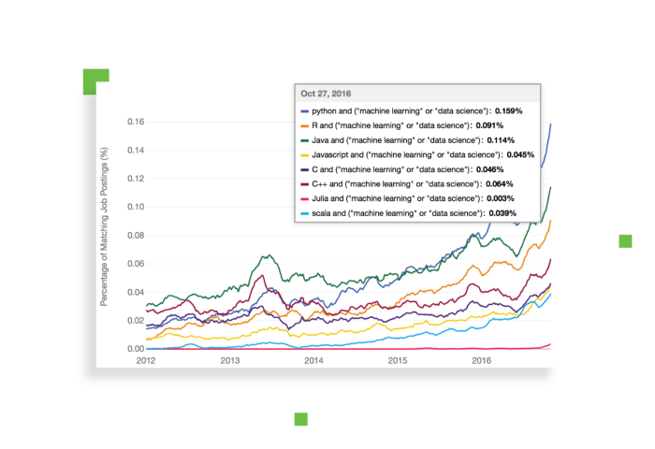

Figure 4. Languages for ML Tread search results

(indeed.com)

Python has access to loads of resources and having a great choice of libraries which is one of the main reasons that python is the most popular programming language for AI. With ML requiring a lot of data processing, python libraries allow you to access and transform this data. With in-built functions that facilitate data analysis and processing, cleansing, modelling, and visualization. Python also has access to very good libraries for both text processing and machine learning such as NLTK, Genism and scrapy for text processing and PyML, Orange and MDP for machine learning (Sabah Mohammed, 2013).

The libraries that will be used within this project for creating the spam classification filter are –

* Pandas – Pandas is a high-level data manipulation tool that uses the NumPy package. The data structure is referred to as the Data Frame that allow you to store and manipulate data within rows and column, as well as allowing gathering from external sources.
* NumPy – NumPy is a tool used to work with arrays and contains multi-dimensional array and matrix data structures. The tools can be used to perform a multiple of different mathematical operation on arrays and the panda’s library relies on NumPy to work and offers an extension.
* Scikit-learn – Handling of basic ML algorithms such as Naïve bayes, clustering, logistic regressions, regression, classification, and others.
* CountVectorizer – CountVectorizer is a tool that is used to convert given text into a vector based of the word count of the text. It works by creating a matrix and each word is represented by a column in the matrix.
* NLTK Stopwords – The Stopwords library contains English word that do not have much meaning within a sentence. They are words such as the, I, was etc. these words can be ignored without sacrificing the sentence. This will allow the removal these words from emails to filter more effectively.
* Tokenize - Tokenize is a tool used to divide big chunks of text into smaller parts called tokens. The tokens are then useful for finding patterns and is considers a based step for stemming and lemmatization.
* Matplotlib – Matplotlib library is used to plotting graphs and figures for example line charts, pie charts, etc. This allows the visualization of the data to understand and recognize patterns easier.
* Seaborn – Seaborn library is used for python data visualization based on matplotlib. It provides a provides a high-level interface for drawing attractive and informative statistical graphics.
* MultinominalNB – MultinominalNB library is a Naive Bayes classifier used that is suitable for word counts for text classification.

# 4.0. 1st Prototype

## 4.1. Design

From the background research conducted into spam email classification, many sources have indicated a particular process to implement a Naive Bayes model into a spam detection filter. As Naïve Bayes is a text-based classification method there are many steps that must be done before and after to create an accurate spam email detection model. Starting with retrieve the dataset that will be used for the training of the model. The data will be analyzed showing key information such as the spam to ham ratio and will allow the cleaning of the dataset where only key information needed will be kept.

Once the data is an analysed the next step is text processing this is where all punctuation and stop words identified within the data analysis section are removed. Each word within the email will then be separated so that the algorithm can identify each word separately and calculated the frequency that the word appears with an email and the frequency within spam emails as a collection. The collection of words is then stored within a bag of word with will allow each word to have an individual weighting symbolizing the probability that a word will appear within a spam or ham email.

The next step is to vectorize the data using the NumPy library this is important as it will allow for the optimization of the algorithm as it implemented from scratch. By doing this it will reduce the errors and compute to get the best parameters for the ML model. Once vectorized the Naïve Bayes training model can then be implemented and using the data provided to it the model can be trained to make accurate predictions.

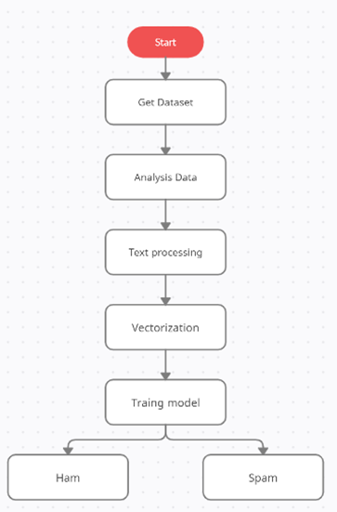Last step is to take all the steps above and to create a data pipeline. The data pipeline is where the text processing, vectorisation and ML model can be stored. This will allow for test data to be passed through the pipeline and accurate prediction are made as each step of the process has been completed.

Figure 5. Spam Detection Model Structure

## 4.2. Implementation

### 4.2.1. Dataset

The dataset is arguable the most important part of the part of the process as it contains all the data that the model will used to be trained. Before training the model, it is important to convert the raw data into a clean dataset this process is called data pre-processing. Pre-processing is needed as a lot of the time data is collected from multiple sources where there can be a difference in the quality of data. The data can contain missing data, noise, and inconsistent values these can affect the accuracy and efficiency of the data. Therefor preprocessing must be applied to enhance the reliability of the dataset (Bhaya, 2017).

The dataset used for this project is a collection of text data know as a corpus. There are specifically 5574 email messages in English within this dataset, that will be used as training data. The Spam Collection is a set of messages that have been collected for Spam research. The files contain one message per line. Each line is composed by two columns the first column containing the label identifying the message as spam or ham. This will allow us to then test the accuracy of the prototype predictions. The second column containing the message as raw text this will be used to correctly identify characteristics and words contained in spam. The third and fourth column contain length and punctation this information will not be needed though out the training process. The dataset is open source and is called “Spam Collection Dataset”, it can be found at www. Kaggle.com (Almeida, 2011).

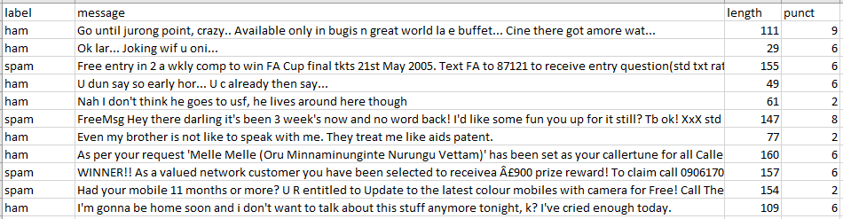

Figure 6. Spam Collection Dataset

The first step is to read the dataset from within the jupyter notebook environment using the panda’s library. The panda’s library allows the use of the read_csv function, this will allow the dataset to be opened and this function can be stored as the variable “email” to be used though out the process of training the model. Once the dataset has been read the information within the dataset can be displayed, the .head() command previews the first 5 entries in the dataset and indicates that the dataset is correctly being read.

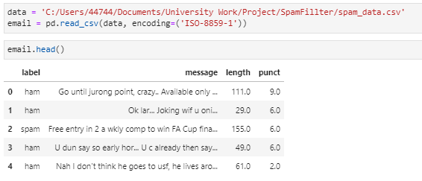

Figure 7. Reading Dataset

### 4.2.2. Data Analysis and Visualization

Data analysis and visualization is an important step as this allows visual representation of the dataset and the data it contains, allowing for the model to be provided with the most accurate training data. By compete the data analysis and visualizing the data though graphs and statistics it will allow further cleaning of the dataset. Through the use of the .describe command it displays key information about the dataset such as the count, mean, min and max.

By analyzing the dataset its clear that for the purpose of training the Naïve Baye classification model that the length and punct columns are not needed. The .drop command was used as this allows the removal of columns leaving an (5574, 2) shape to the dataset.

While analysing the dataset its important to know what ham and spam emails are within the dataset and this allows you to understand the difference between a spam and ham messages as well as providing information on the number of spam and ham messages within the dataset. This was done by calling all the “ham” and “spam” within the label column of the dataset. This showed that there were 4827 ham and 747 spam messages.

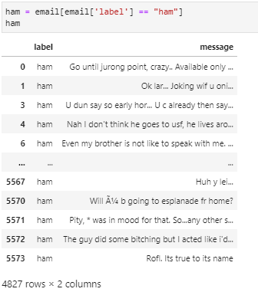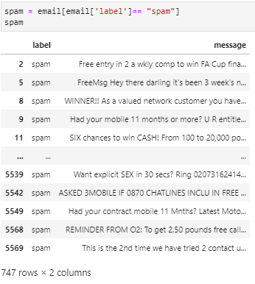

Figure 8. Dataset Spam Messages

Figure 9. Dataset Ham Messages

For further visualisation of this data with the use of the seaborn library and the .countplot command this allow the results for spam to ham ratio to be displayed within a bar chart. This allowed the data to be better visually represented. The percentage of spam contained within the dataset was then calculated and displayed to provide need data for training the model as this information would be necessary to access the dataset. This was calculated by the amount of spam messages divided by the total number of messages multiplied by 100 giving the spam percentage.

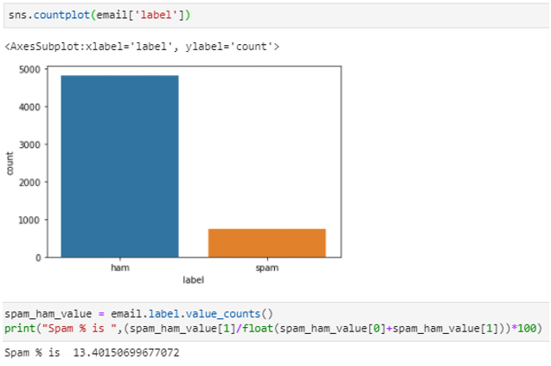

Figure 10. Dataset Spam/Ham Split

### 4.2.3. Text Preprocessing

Text preprocessing is essential for machine learning. This is because text data can have hundreds of thousands of dimensions (words and phrases) but tends to be very sparse. The English language contains 470,000 dictionary English words and with many of them being linking words with no meaning. As emails only containing a few words, it is important to remove these words from the text data to have a model that can provide the most accurate predictions (LEXALYTICS, 2020).

The implementation of the NLTK Corpus Stopwords is a useful library as it contains a list of the “Stopwords” within the English language. Stopwords is a list of commonly used words that add no meaning within a sentence such as “the”, “a”, “an”, “in”. From research conducted the words “subject” and “http” appear frequently within both ham and spam emails so these will be adding the list of stop words to be removed.

Within the text process function it starts by first removing all punctuation within the email corpus. It then identifies and splits the sentence into individual words and joins the words together to form a string. Lastly once all the punctuation has been removed the Stopwords are removed from the final string. This process is called tokenization, this is the term used to describe the process of converting the normal text strings into a list of tokens (words with meaning) so that a machine can understand. This ensures that the model is only using key words to identify spam/ham and prepares the data to be vectorised.

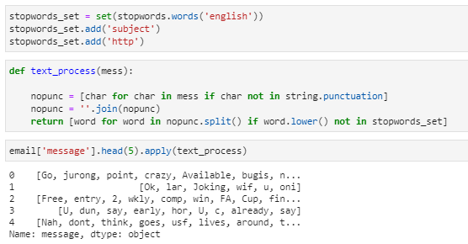

Figure 11. Text Processing

### 4.2.4. Vectorization

Vectorization is a methodology in NLP to map words or phrases from vocabulary to a corresponding vector of real numbers which used to find word predictions, word similarities/semantics (Prabhu, 2019). Currently messages are stored as a list of lemmas (tokens), the vectorization process will allow the SciKit Learning algorithm to understand the information. To convert messages shown as tokens into a vector format the bag of words approach will be use, this can be split into three steps:

1. Count the frequency a word appears in each message.

2. weight counts with frequent tokens getting a lower weight.

3. Normalize vectors into unit length.

Currently, the vectors will have many dimensions as the are many unique words currently in the spam/ham messages corpus. The Scikit CountVectorizer library will be implemented to convert the messages into a token count matrix.

Figure 12. demonstrates the use of the CountVectorizer to get the total amount of unique vocabulary words within the messages after the text processing has removed all punctuation and words with no meaning. The result is a number indicating the amount of vocabulary words found.

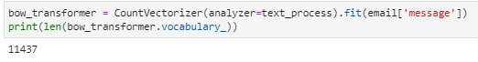

Figure 12. Vocabulary count

A demonstaration of this process is done within figure 13 to show a visual repersentation of what is happening. Firstly figure 13 shows all the vocabulary words within message four, the message is also shown in its vectoristed format allowing the identification of unique words within the message as well as identifying repeated words after the stopwords have been removed.

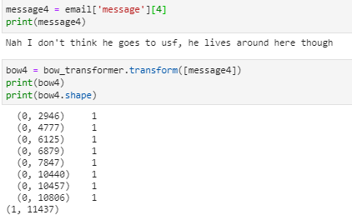

Figure 13. Identifying Unique Words

A sparse matrix is represented with a 2-dimensional array, where the 1-dimension is the entire vocabulary (1 row per word) and the other dimension are the actual documents, in this case a column per message. The sparse matrix can then be created with the use of the .transform on the bag of words. This transforms the entirety of the corpus using bag of words to count the messages and then transforms in a sparce matrix displaying the shape of the matrix, Nonzero occurrences, and the sparsity.

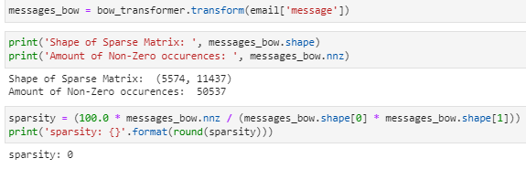

Figure 14. Sparse Matrix

The next step is to work out the weighting of each unique word this is done by using TF-IDF which stands for term frequency-inverse document frequency. The TF-IDF weight is a statistical value that is used for computing the importance of a unique work within the data corpus. The words importance is computed by looking at how many times the unique word appears within the text but also looks at the frequency that the word appears within the data corpus. This can be split into two parts the Team frequency and Inverse Document Frequency.

Team frequency is the number of times that a word appears with an email and is then divided by the amount of words within the email. The possibility of a word appearing more within larger bodies of text is more likely that is why the frequency is calculated. This is shown as:

***Number of Appearance in Emails***

**TF = ----------------------------------------------------------------------** Equation . Team Frequency

***Number of unique Words in Emails***

Inverse Document Frequency is the total number of emails within the dataset divided by number of emails containing the unique word. This will be used to measure the importance of the terms, while computing the weights for the terms the words are at an equal importance. The rave terms will be scaled up and commonly used terms will be scaled down. This is shown as:

***Number of Emails***

***IDF = --------------------------------------------------------------------***

Equation . Inverse Document Frequency

***Number of Emails Containing Unique Word***

Figure 15. Show an example of the TF-IDF weights for the unique words that are contained within the fourth entry within the dataset. It also shows the shape of the entirety of the bag of words converted into the TF-IDF model.

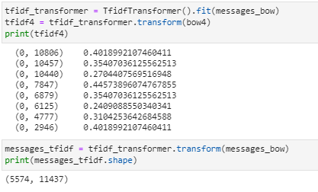

Figure 15. Word Weights and Bag of Words to TF-IDF corpus

4.2.5. Training Model

After the vectorization, the training model can now be implemented as all the messages are now shown and represented as vectors. This is importance as this allows the computer to use and understand this information. The Naïve Bayes classification algorithm has been chosen and implemented within this project as from the background research it has shown that it is well used in the industry and will produce an accurate prediction model when sufficiently trained.

The implementation of the Naïve Bayes classification involved first using the Sklearn Naïve Bayes library to import MultinominalNB allowing the classification of word counts for text classification. From this the model could be tested on individual messages within the dataset by supplying the tfidf word weights and the labels indicating spam or ham. Figure 16 shows this process where the fourth entry within the dataset was used and an accurate prediction of ham was made.

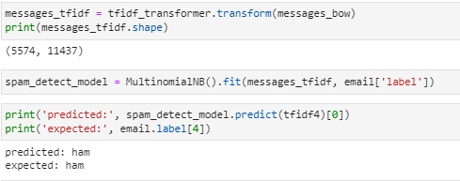

Figure 16. Naïve Bayes Training model

To evaluate the model to determine how well the model worked over all from the training data set each entry in the dataset was passed though the model and a prediction was made. This was then compared to the label indicating if it was spam or ham. The Sklearn metric library was used to import classification report where the information was passed and was able to show the overall accuracy of the model.

Figure 17. shows the classification report. This shows that the model had an accuracy of 98% showing that the model is working and making accurate prediction. Although this is not a good representation of the model’s true accuracy as its being tested on the same data being used to train the model. This does not really explain much about the overall predictive power of the model.

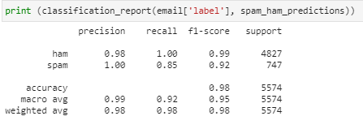

Figure 17. Model Evaluation on Training Data

### 4.2.6. Data Pipeline

The definition of a pipeline according to Sklearn is “Sequentially apply a list of transforms and a final estimator. Intermediate steps of pipeline must implement fit and transform methods and the final estimator only needs to implement fit” (SciKit Learn, 2017).

The Pipeline is needed to help enforce the required order of the steps the model must take to create convenient workflow, ensuring reproducibility of the work. The pipeline works by first getting the string to token integer count, then integer counts to the weighted TF-IDF scores and lastly it is trained using the naive Bayes classifier. Shown in figure 18.

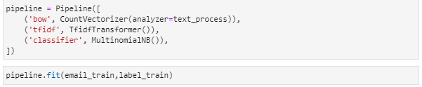

Figure 18. Pipeline Implementation

### 4.2.7. 1st Prototype Testing

The first step is to create a training test split, this is the first step to testing the model to ensure that an accurate indication of how accurate the model predictions are is given. This process involves splitting the dataset into two sections training data and test data. This ensures that the model will never see the test data throughout the train stage. So, will be able to make prediction not having seen the data before.

The dataset was split 80/20 so that 80% of the dataset would be used for the training of the model and the remaining 20% would not have been used to train so will give an accurate representation. The model will be provided 4459 email messages for training data and 1115 are allocated to the testing data.

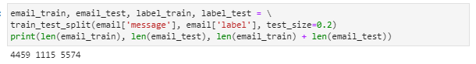

Figure 19. Splitting Dataset to Training / Test Data

The training data is passed into the pipeline it will perform pre-processing and then the test data can be passed into the pipeline so that the predictions can be made. The predictions are shown in a classification report so that they can be analysed.

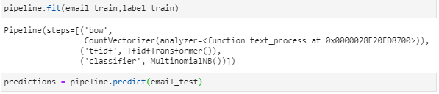

Figure 20. Pre-Processing

The Classification report shows the prediction of the test data were 97% accurate overall. This shows an accurate indication of the prediction power of the model as it is correctly identifying spam and ham email messages using text classification.

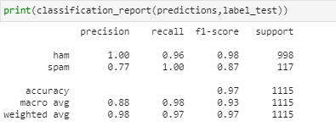

Figure 21. Test Data Classification Report

## 4.3. 1st Prototype Evaluation

Overall, the 1st prototype was very successful at showing the prediction power of the Naïve Bayes model produced. With the overall accuracy score of 97% within the testing using an 80/20 training test split the model has shown that it can accurately predict spam emails from the data provided within the training dataset.

Although throughout the process of creating the model numerus dataset were tested to train the model to discover which one produced the best result from detecting spam emails. This process is tedious but extremely necessary to gather information about the datasets fit within this spam classification model as the model is only as strong as the training data provided.

After finally settling for the dataset shown throughout the development the model, it was identified that currently the model is not presented in a user-friendly or a way that an average everyday person would be able to use. Therefor the further development within the final prototype would be to introduce the model into a web framework allowing the users to check individual emails by providing the email body.

# 5.0. Final Prototype

## 5.1. Design

After the evaluation of the first prototype and the issue noted of the user friendliness and ease of use the work begun on the final prototype. The final prototype will be working on the implementation of the Naïve Baye model into a Django web framework. The Idea was to have a website where users could enter the email body into a text box and where the model would then make a prediction from the data provided using the Naïve Baye model.

Figure 22. shows the flow diagram of the process of the final prototype. Firstly, as within prototype 1 the model needed to be trained by providing training data, the data then had to be pre-processed this is the cleaning of the data removing all noise from within the dataset. Feature engineering includes pre-processing methods used including Term Frequency-Inverse Document Frequency(TF-IDF) and bag of words to provide the required information for the training of the Naïve bayes classification.

Once the data was processed the Naïve bayes classifier was trained and an evaluation of the model’s was performed. The next stage is taking the model and implementing into a web framework. The website would work by users inputting a new email message as raw text. The message would then be subject to the required stages of pre-processing and then the Naïve Bayes models would make a prediction on if the email message entered indicating if it is spam or ham.

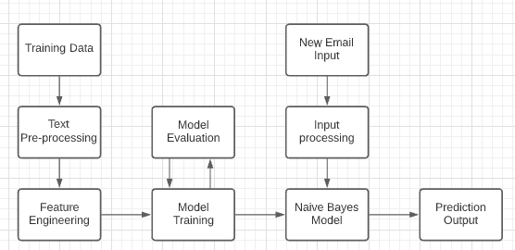

Figure 22. Final Prototype Flow Diagram

## 5.2. Implementation

### 5.2.1. Django Web Framework

What is Django? Django is a high-level open-source python web framework used for rapid development and clean and pragmatic design. Django apps are reusable with the ability to be used over multiple projects and almost independent components. Django offers a large collection of modules useful for the project and since Django is written in python it is a great choice for deploying the machine learning model.

To start the project within windows firstly a python virtual environment needed to be set up and the libraries used within model installed. The purpose of creating the python virtual environment is to have an isolated environment for the specific project. This allows the project to have its own independent dependencies and changes can be made regardless of other projects.

The next step was to install Django using “pip install django” this then allowed the creation of a folder for the project using “mkdir django-project”. Next to create the Django project with “django-admin startproject SMD” this set up the file and folders required. Now the project can be run using “python3 manage.py runserver” and by then going to the local host it shows the successfully Django installation.

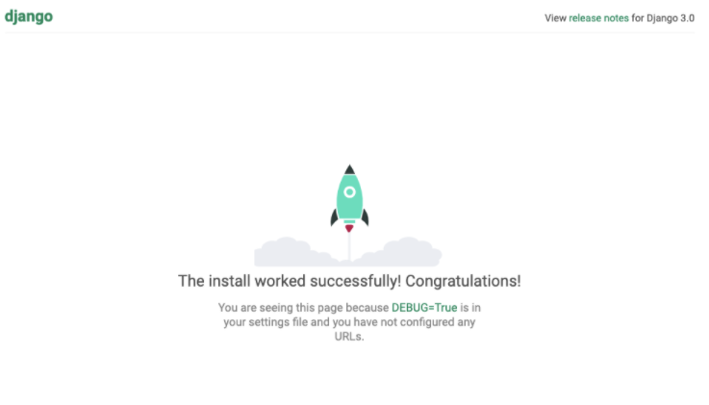

Figure 23. Successful Django installation

The next was to set up the correct file structure for the Django project. This involved created a template and static folders to store the files need for the successful creation of the front end. The templates folder is used to store the HTML pages and the static folder would contain the CSS files, fonts and the image that will be used for the design of the website.

### 5.2.2. Designing Web Interface

The web interface is an import part of the project as it will be the first thing that is seen by the user and will be used to show off the model. The web interface has a set of criteria that it must incorporated to be successful.

Firstly, the web interface must be physically appealing and look professional this is important as the appearance will give the first impression when visiting the website. The web interface must also be informative and describe to the users the purpose of the website as well as telling them how it works. Lastly, the website must have a text box enabling the user to be able to enter their emails to meet the main objective of the website to showcase the model.

The mock design below shows the thought process of the web interface before the development stage. Although the mock design is simple it shows that all key areas of the of web interface criteria have been thought of and addressed. There is a section on the left containing information about the website as well as providing a guide on how to use the model. There is also a large text box provided within the centre allowing for the email body to be pasted into and with the click of the “predict email” button the information entered will be checked though the model and a prediction is made displaying the results.

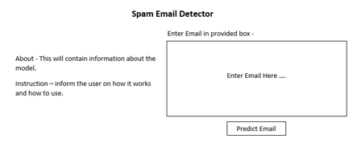

Figure 24. Web Interface Mock Design

By using the mock design, the creation of the web interface started by creating page call index.html within this the structure and design of the home page interface is created. The creation of the web page started by setting the viewport to the width of the device that its being viewed on ensuring that webpage had the ability to be viewed on any size device and was done by using bootstrap. The next step was adding both bootstrap and jQuery this was simply done by including the URL link to them both within the head of the page and at the bottom of the body tag.

Bootstrap is a front-end web framework that is used for developing a responsive and mobile friendly website. It includes HTML and CSS based design templates for typography, forms, buttons, tables, navigation, modals, image carousels and many others. Whenever a bootstrap call is made it automatically know what to do in that situation, for example it will know it should have a certain margin or padding number (JavaTpoint, n.d.).

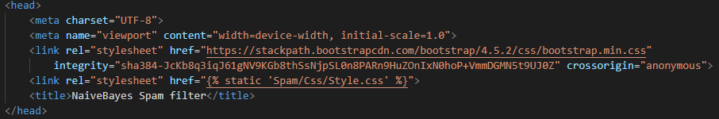

Figure 25. Adding Bootstrap

Many of the bootstrap feature were used within creation of the web interface. Firstly, bootstrap navigation bar to have a navigation header at the top of the page, this needed to hold the website name web API and app. Another bootstrap feature that was used was the bootstrap grid system this allows up to 12 columns across the page. For this project, they were grouped together into 2 columns using “col-md-6” allowing the page to be structure so that about information was on the left and the text box with a make prediction button was on the right.

The html file is structure so that it is split into 3 parts header, main content, and form. The main content contained a welcome to the project and the information needed on how the project worked and could be used.

The form part contains the adding of the text box for the raw email text data to be entered, this will allow the user to add the text body from an email where a prediction will be made from using the model. It also contains the radio button that shows that current prediction is going to be made using “Naïve Baye”. By having a radio bottom this give an option for future development of the project as different machine learning algorithms can be add onto a new radio button allow the testing and comparisons of different machine learning algorithms against each other. A button was added lastly so that when it is pressed the raw data is used to make the prediction.

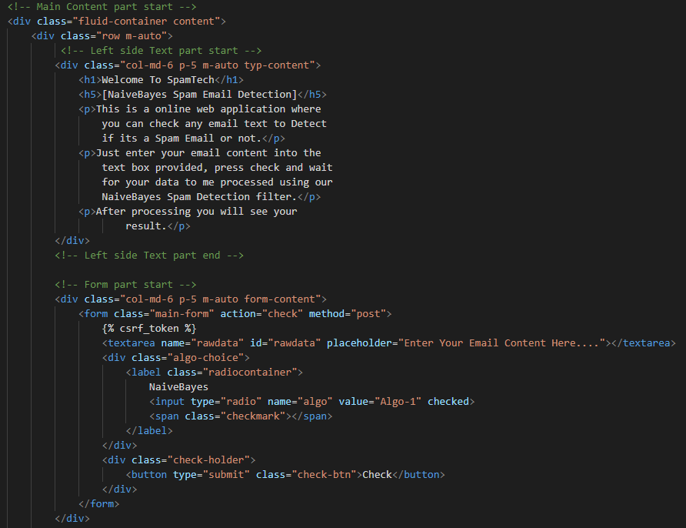

Figure 26. Index.HTML Code

The next step is to create the Style.css file this contained all the code for the look of the website including fonts, sizes, positioning of the text and background image. There were multiple fonts used within this project so the first step was to import the font from the font file so that they could assigned to various bodies of text. The background image is set within this file and was choice as it is an ai futuristic image this fit the machine learning theme of the project. Lastly after all the styling was created the file it was stored within the static folder; the static folder is then called within the HTML page. Figure 27 shows the design of the web interface, the interface meets the criteria set providing a professional and informative design.

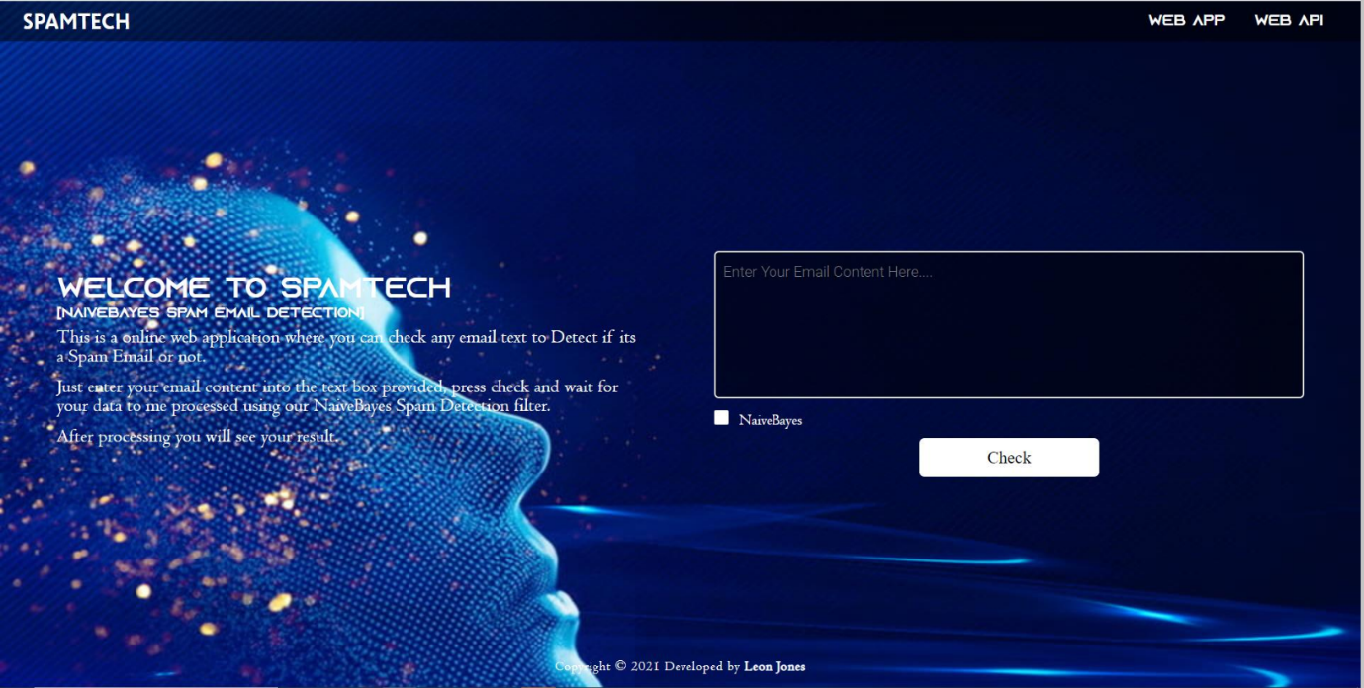

Figure 27. Webpage design

### 5.2.3. Linking ML Model

Now that the web interface has been designed the model can now me implement. To do this the model had to first be pickled so that it can be used within the Django web framework. After the machine model is created and trained you are left a model object and to use the model it needs to be save or the model will have to be trained each time it is used which is extremely inefficient. Picking is the process of serializing and de-serializing Python objects. This will convert python objects such as lists and dictionaries into byte streams, these byte streams can then be converted back into Python objects by unpickling.

Figure 28 shows the Machine learning model created and trained within the first prototype being pickled. To pickle the model the joblib library is being used as this out preforms the standard pickle and Numpy in terms memory consumption. To pickle the model the Joblib.dump method was used to dump the python object into a pickle file call “modelpipeline.pkl” this is then stored within the directory.

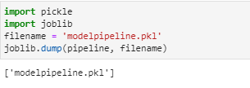

Figure 28. Pickling Model

Now to use the model within the Django framework the pickle file had to be loaded and unpicked within the views.py file. This was done by using the joblib .Load command followed by the file name and this would then allow the model to be used. By having the model within the views file this allowed the model to be assigned to the radio button.

Within the views file the index page is firstly called as this is the page that the model with be run from. The next step is to create the “checkspam” function, within here there is a check this will make sure that the naïve bayes radio button is checked and that predict button has been pressed. It then creates a variable “finalAns” set to none as this will contain the prediction once it has been made. It also gets the radio button selected this has been implemented so future development of models using other machine learning techniques and algorithms can be completed and easier incorporated within the framework.

The rawData variable contains the information that the user has entered into the text box provided on the website this then allows the information to be used so that the prediction can be made. Another check is made to see the model that has been selected to make the prediction in this case the Naïve Bayes model. It then called the model and makes the prediction using the raw text that has been entered into the textbox.

Lastly it uses the prediction that is made and preforms a check within output.html page. This will check will get the output.html page and ensure that based on the prediction the correct information is load and displayed to the user.

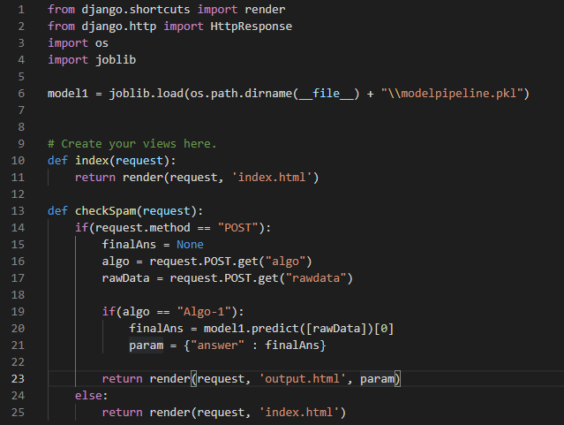

Figure 29. Model Integration into Django Web Framework

The output html page is the page that will be displayed to the user once a prediction has been made based of the raw data provide. Depending on the prediction the text shown will change, if the prediction is “ham” then “Not Spam (Ham)” will be display and if the prediction is anything else then “Spam” will be display.

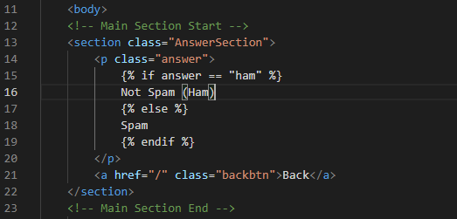

Figure 30. Output Displayed Decision

Within figure 31 it shows the outputs displayed for both Spam and Ham prediction. The output page also contains a back button so that multiple predictions can be made.



Figure 31. Results Pages

# 6.0. Testing

Before testing the project, research of common word used within spam emails and analyse of the dataset used to train the model needed to be completed. Typically spam words can be grouped into six categorises manipulative, needy, sleazy, cheap, far-fetched, or too good to be true. This helps to obtain a list of spam words and praises that are commonly used within spam emails today. The presences of these words being contained within the raw data entered the model should make a prediction of spam. The list below was obtained via (Margo, 2020) -

* Winner
* To claim
* Valid
* Win
* URGENT
* Free entry
* T&C's apply
* Unsubscribe
* Congratulations
* Specific Values (£1000)
* Prize reward
* Claim
* Valued customer
* Bonus
* Awarded
* Guaranteed
* Claim Code
* 100%
* Cash
* Reply STOP to opt out.

To assess the prediction power and accuracy of the model multiple tests were done using spam and ham email messages. The spam messages were constructed from the research and using some of the words within the lists shown above. The email messages will be entered into the text box as raw data and using the Naïve Baye model a prediction will be made this process will be repeated for 3 email messages. For each test, the expected result will be giving as well as the reason for why the prediction should be spam or ham.

**Prediction Test 1**

Email Message - “Winner! Congratulation on winning the cash prize. Click the link below to claim.”

Expected result – Spam.



Figure 32. Test 1 Results

Results – Figure 32 shows the email message being tested and the prediction of spam being made. This prediction is accurate and is the expected result as there are multiple common spam words frequently used withing the text provided. This shows that the model is correctly works and following the process to provide an accurate result.

**Prediction Test 2**

Email Message – “Hi Leon, how are you? are you still working on the project .”

Expected result – Ham.



Figure 33. Test 2 Results

Results – Shown within figure 33 the testing of the email message and the prediction of “Not Spam (Ham)”. This prediction was as expected as the email message used within this test does not contain any words that are frequently used with spam emails. This shows that the model can accurately identify personal messages are not spam.

**Prediction Test 3**

Email Message – “ URGENT! You could be entitled up to £3,160 in compensation from mis-sold PPI on a credit card or loan. Please reply PPI for info or STOP to opt out.”

Expected result – Spam.



Figure 34. Test 3 Results

Results – Figure 34 shows the email message being entered into the text box and a prediction of spam being made. This prediction is as expected as the email message used is a spam mail and contains several common spam words. The algorithm correctly identified the common spam words and made the correct prediction.

## 6.1. Testing Plan

|  |  |  |  |
| --- | --- | --- | --- |
| **Test** | **Reason** | **Outcome** | **Retest** |
| 1. **Machine learning algorithm is integrated into Django web framework.** | The machine learning spam detection algorithm should be successful integrated into the Django web framework allowing prediction to be made from the web page. | Success | No |
| 1. **Information entered within text box is taken to make predictions.** | The information that is entered by the user is used to make the spam or ham prediction. | Success | No |
| 1. **Prediction made when using Naïve Bayes model when “Check” button is clicked.** | When the check button is pressed the Naïve Bayes, model is used to make a prediction using the raw data entered. | Success | No |
| 1. **The Prediction made correctly identified if spam.** | The prediction make correctly identifies spam emails. | Mostly successful with small percentage of inaccurate predictions due to small dataset. | No |
| 1. **The Prediction made correctly identified if Ham.** | The prediction make correctly identifies ham emails. | success | No |
| 1. **Stopwords and Punctuation is removed.** | All stop words are removed from the dataset and from the raw data before a prediction is made. | Success | No |
| 1. **Email messages entered in the text box is vectorized.** | The raw data entered is vectorised enabling the SciKit Learning algorithm to understand the information. | Success | No |
| 1. **Term Frequency-Inverse Document Frequency (TF-IDF) weights assigned to unique words.** | The TF-IDF weights are assigned to the words within the dataset. | Success | No |
| 1. **The back button goes back to the main page for other prediction to be made.** | When the back button is pressed on the output / predictions page it should go back to the main page. | Success | No |
| 1. **The webpage fits the size of web browser or device it is viewed on.** | The web page fits the width of the browser or device using boot strap. | Success | No |

## 6.2. User Feedback

As you can see from the testing plan above all tests were successful. The next step was to move to testing the project with real people allowing them access to the spam filter for real-time testing.

Five university peers were gathered and granted access to the website to test spam detection model. They were asked to enter a variety of different email messages that were both ham and spam to show the capabilities of the model’s predictions. After they tested the model, they were asked to give feedback that could be used for further development. The questionnaire was conducted using google forms enabling a good visualisation of the feedback gathered.

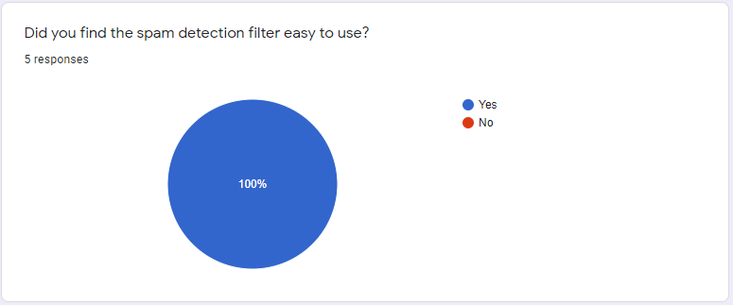

Figure 35. Feedback Question One

Figure 35 shows that all five of the users found the spam detection filter easy to use and no issues were encountered when checking if their email message was spam.

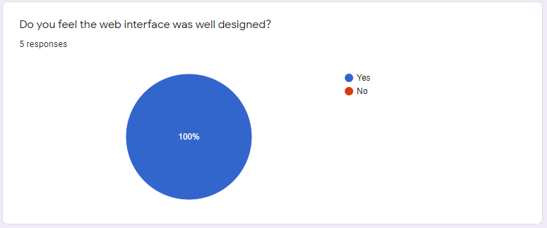

Figure 36. Feedback Question Two

Figure 36 shows that all participants thought that the web interface was well design. This is important as one of the goal set was to create an eye catching and look professional, this feedback shows that the goal was met.

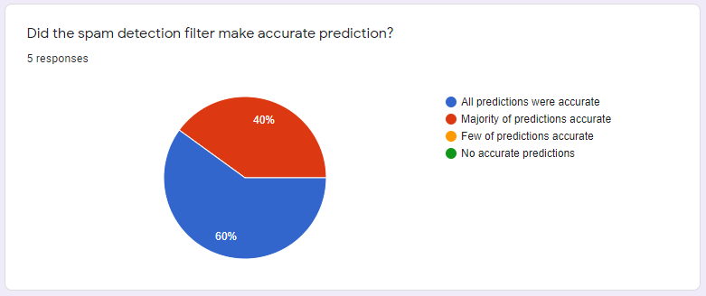

Figure 37. Feedback Question Three

The feedback shown in Figure 37 shows that the model was correctly identifying spam emails the majority of the time but due to the small dataset used for the training process there are some instances where spam emails are miss interpreted as ham emails. This is a positive result as it shows that the model is successful in predicting spam and with the more training data this issue will be resolved.

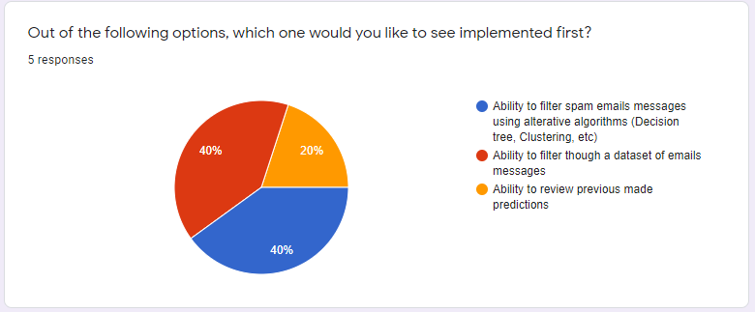

Figure 38. Feedback Question Four

The of question four was to get feedback for features of the spam detection filter that the users would like to see added first. From this it has shown that all three ideas were liked by the users as they all received a vote, but there was a split decision for the feature they wanted first between including more algorithms to make predictions and being able to filter dataset as well as single email messages.

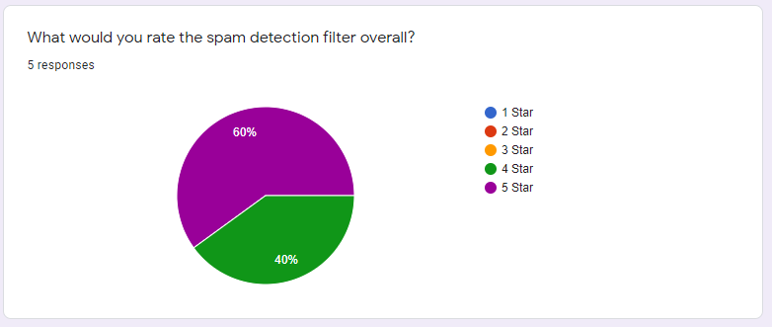

Figure 39. Feedback Question Five

Figure 39 shows the overall rating the users have given the spam detection after being able to use it and test the prediction capabilities. The response was very positive with users scoring it between 4-5 stars which is excellent result given this is the initial development of the project and shows that the model is providing mainly accurate prediction and a good overall user’s experience.

# 7.0. Objectives Review

At the beginning of the dissertation six objectives were set. The objective outlines the target goals that must be met to achieve the project aim. Below all six objectives succession are discussed –

**Objective 1 - Research the reason why we need spam email detection, and the impact spam is having on both uses individual users and businesses.**

Within the background research the main reason why spam email detection needed are discussed, identifying the types of spam emails and the rapid growth of spam emails being sent within the last 30 years. Also, within the research it discusses the intended purpose of the spam emails such as phishing attacks and the drastic impacts that these can have on individuals and businesses.

**Objective 2 - Research and explore spam filtering tools that are available and gain an understanding on the ML algorithms used to detect spam emails.**

The background research conducted looked at a variety of different spam filtering tools and machine learning algorithms. Within this an in-depth analysis of the different machine learning algorithms conducted showing how each of them work via diagrams and equations. The research identified that Naïve Bayes was the most practical for the project due to its ease implementation and it being widely used within the spam filtering industry.

**Objective 3 - Research the different languages used to detect spam emails and gain understanding on the security aspect.**

Research was conducted into the different languages available for machine learning from this python was identified to be the best fit for the project. This is due to the large range of python libraries available for machine learning such as Pandas and NumPy. The security aspect of this project has also been achieved as spam filtering algorithm provided a level of security to its users making accurate prediction identifying spam emails.

**Objective 4 - Use the research to identify the optimal tools and algorithms to create a spam emails detection classifier that should accurately predict spam emails.**

Using the research gathered it was identified that the Naïve Bayes classification was the best approach accompanied by TF-IDF and bag of words. The project started by selecting a dataset that would be used to train the model, the selected dataset had to be cleaned removing all the noise and irrelevant information. The Stop words and punctuation were removed so that only words with meaning was left. The words left would be assign a TF-IDF weight and then the Naïve Baye classification would be used to make a prediction based of the training data. This process was documented in prototype 1 and the model’s accuracy of 97% was shown within the classification report.

**Objective 5 - Improve spam email detection classifier and develop a web application to allow testing of the developed spam filter.**

The development of the final prototype integrating the machine learning model developed in prototype 1 into the Django framework enable the model to be easily used to make predictions based of individual emails. The incorporation of the model into the Django framework was documented within the final prototype and allowed the model to me easily used to make predictions.

**Objective 6 - Test the spam email detection classifier to ensure that it is accurately detecting spam emails.**

The testing was split into three selections individual prediction tests, a testing plan and user feedback. The individual tests involved testing spam messages constructed from common spam email words and ham messages to check the predictions are accurate. The testing plan was used to tested individually features withing both the model and the web framework to ensure that there are functioning correctly, and the user feedback was used to provided constructive feedback and users opinions on further development.

# 8.0. Conclusion and Future Appraisal

The main goal of this dissertation project was to create a machine learning model for spam email detection. This goal was met, as the spam filtering model developed can accurately predict spam emails successfully and was integrated into a Django web framework for individual email predictions. The Naïve Bayes algorithm in conjunction multiple machine learning tools and libraries was used for the creation of the model that was trained from a spam and ham dataset allowing the model to make intelligent predictions.

The project aim was to research and gain understanding on detection of spam email by using ML algorithms and to develop a spam filtering algorithm using modern techniques and tools. Within the project extensive research was conducted identifying multiply tools, machine learning algorithms available and their fit for purpose within this project. After comparing the pros and cons for each of the algorithms the Naive Bayes was best suited for this project.

Throughout the project an agile approach used to manage and plan the project efficiently. This approach would allow for constant development and testing to be carried out throughout the project’s life cycle using a five-step loop approach. Using GitHub and Trello it allowed for excellent planning for each stage of the project setting dates for when each stage needed to be completed ensuring that the project was complete on the set deadline.

Using the agile approach identified that the first prototype which was the development of the spam detection model needed to be displayed within a web framework allowing single email predictions and providing a better user experience. The model was then integrated into the web framework within the final prototype successfully addressing this issue.

Throughout the development of project there were several issues that were encountered that need to be overcome. The main issue was the dataset originally used for the training of the model as at first glance it appeared to be a dataset of English words and phrase but after careful inspection it the dataset contained emails in a multiple of different languages which would not provide an accurate model to detect English spam email messages. This issue was partially difficult due to the time constraints and the limited open-source resources available although it was over come as a new dataset was found containing only English messages.

From the testing carried out within this project it was identified that the model was successfully meeting the requirement set for the project. The testing also flagged that the spam filtering algorithm was sometime making incorrect prediction identifying a small minority of spam messages as ham. This was due to the spam detection filter only being as accurate as the dataset that was provided to train the model. Due to lack of time and resources an open-source dataset had to be used containing only 5574 email messages, in an ideal situation and given more time the dataset used to train the model would be significantly bigger allowing the spam filtering model to have more information available to it subsequently drastically improving the overall prediction power of the model.

As well as this future development of the model would include further development of normalisation techniques such as stemming. Stemming is the process of reducing inflected words to their word stem or root, the incorporation of stemming would help to prevent spammers using techniques to work around the algorithms and would significantly improve the predicting power of the algorithm.

The feedback identified further development opportunities if given more time this would include the development of the Django web interface adding features such as insert database allowing uses to enter a dataset of emails for multiple prediction to be made at once displaying the percentage of spam containing within the dataset. Another feature wanted was the ability to uses multiple algorithms as this would give option to compare algorithms prediction power.

To conclude, the project has achieved the set aim and objectives set out within the beginning of the project. The spam detection filter that has be that has been developed using Naïve bayes classification successful identifies spam and ham email by taking the raw information entered by users and makes accurate prediction.

Link to video demonstration –

<https://www.youtube.com/watch?v=C10if8cV21Q&ab_channel=SpamTech>

Link to Google forms questionnaire –

<https://docs.google.com/forms/d/e/1FAIpQLScM14QXGhg05uy8MlpQySTN6q_EUwAOfX2VaH0OlvveOfUF3A/viewform?usp=sf_link>

Link to drop box containing code –

<https://www.dropbox.com/sh/x7mmkwfyspsh4he/AAC2CuKynfeY-DuObn7S_QZza?dl=0>

# 9.0. References

A Al-Allak, R. L. (2010). The Naïve-Bayes Decision Tree (NBTree) Classifier. *Predicting the Probability of Survival in Breast Cancer*, P4-09-19.

Ajibuwae, E. (2019). Review, approaches and open research problems. *Machine learning for email spam filtering:*, 1-9.

Almeida, T. G. (2011). *A. Contributions to the Study of SMS Spam Filtering: New Collection and Results*. Retrieved from www.kaggle.com: https://www.kaggle.com/uciml/sms-spam-collection-dataset

Berndt Müller, J. R. (1995). *Neural Networks.* Springer-Verlag Berlin Heidelberg.

Bhaya, S. A. (2017). Review of Data Preprocessing Techniques in Data Mining. *Journal of Engineering and Applied Sciences*, 4102-4107.

ELseuof, W. A. (2011). MACHINE LEARNING IN E-MAIL CLASSIFICATION. *MACHINE LEARNING METHODS FOR SPAM E-MAIL*, 173-184.

FilterLevent Özgür, T. G. (2004). Artificial Neural Network Classification. *Spam Mail Detection Using Artificial Neural Network and Bayesian Filter*, 2-6.

García-Gonzalo, E. (2016). support vector machine (SVM). *Hard-Rock Stability Analysis for Span Design inEntry-Type Excavations with Learning Classiﬁers*, 7.

Gunn, S. R. (1998). Support Vector Classification. *Support Vector Machines for Classification and Regression s.n.*, 4-16.

Hayati, P. (2010). *Definition of spam 2.0 - New spamming boom.* Zanjan, Iran: Institute for Advanced Studies in Basic Sciences.

Insu Park, R. S. (2016). The Effect of Spam and PrivacyConcerns on E-mail Users'Behavior. *The Effect of Spam and PrivacyConcerns on E-mail Users'Behavior*, 61-64.

JavaTpoint. (2020, January 3). *Decision Tree Classification Algorithm*. Retrieved from www.javatpoint.com: https://www.javatpoint.com/machine-learning-decision-tree-classification-algorithm

JavaTpoint. (n.d.). *What is Bootstrap*. Retrieved from www.javatpoint.com: https://www.javatpoint.com/what-is-bootstrap

Kiamarzpour, F. (2013). J48 Decision Trees. *Improving the methods of email classification based on words ontology*, 262-266.

Kriegel, H.‐P. K. (2011). Density-Based Clustering. *WIREs Data Mining Knowl Discov*, 231-240.

LEXALYTICS. (2020, September 29). *Machine Learning (ML) for Natural Language Processing (NLP)*. Retrieved from www.lexalytics.com: https://www.lexalytics.com/lexablog/machine-learning-natural-language-processing#:~:text=Machine%20learning%20for%20NLP%20and,known%20as%20supervised%20machine%20learning.

Luashchuk, A. (2019, May 29). *Why I Think Python is Perfect for Machine Learning and Artificial Intelligence*. Retrieved from towardsdatascience: https://towardsdatascience.com/8-reasons-why-python-is-good-for-artificial-intelligence-and-machine-learning-4a23f6bed2e6

Margo, L. (2020, Febuary 2nd ). *autopilotapp*. Retrieved from 202 email spam trigger words that will get you in trouble in 2020: https://journeys.autopilotapp.com/blog/email-spam-trigger-words/

Mohamed, G. (2014). E-Mail Phishing . *An open threat to everyone*, 1-4.

Namestnikova, M. (2012). *Spam Report: April 2012.* Kaspersky Lab.

Patil, T. a. (2013). Performance Analysis of Na¨ıve Bayes and Classification Algorithm for Data. *International Journal Of Computer Science And Applications*.

Prabhu. (2019, November 11). *Understanding NLP Word Embeddings — Text Vectorization*. Retrieved from towardsdatascience.com: https://towardsdatascience.com/understanding-nlp-word-embeddings-text-vectorization-1a23744f7223

Rusland, N. F. (2017). *Analysis of Naïve Bayes Algorithm for Email Spam Filtering across Multiple Datasets*, 10.

S.Ananthi. (2009). SPAM FILTERING USING K - NN. *Journal of Computer Applications*, 20-23.

Sabah Mohammed, S. F. (2013). Classifying Unsolicited Bulk Email (UBE) using Python Machine Learning Techniques. 56.

Sarit Chakraborty, B. M. (2012). Spam Mail Filtering Technique using Different Decision Tree Classifiers through Data Mining Approach - A Comparative Performance Analysis. 26-30.

SciKit Learn. (2017). *sklearn.pipeline.Pipeline*. Retrieved from scikit-learn.org: https://scikit-learn.org/stable/modules/generated/sklearn.pipeline.Pipeline.html

Sharma, M. (2018). EMAIL SPAM FILTERING METHODS. *A Survey of Email Spam Filtering Methods* , 14-18.

Shrivastava, J. N. (2007). Intelligent Systems and Applications. *E-mail Spam Filtering Using Adaptive Genetic*, 55-56.

Society, I. (2015). The Challenge of Spam. *An Internet Society Public Policy Briefing*, 5-11.

The Royal Society. (2017). Machine learning: the power and promise. *Machine learning* , 4-11.

Thomas J. Holt, D. C. (2007). International Journal of Cyber Criminology. *A Qualitative Analysis of Advance Fee Fraud E-mail Schemes*, 137-143.

Wei, Q. (2018). AIP Conference Proceedings. *Understanding of the naive Bayes classifier in spam filtering*, 1-7.

# 10.0. Table of Figures

Figure 1. Decision Tree Example (JavaTpoint, 2020) 11

Figure 2. Nearest Neighbour Model 11

Figure 3. Classification of data by support vector machine (García-Gonzalo, 2016) 12

Figure 4. Languages for ML Tread search results 15

Figure 5. Spam Detection Model Structure 17

Figure 6. Spam Collection Dataset 18

Figure 7. Reading Dataset 19

Figure 8. Dataset Spam Messages 19

Figure 9. Dataset Ham Messages 19

Figure 10. Dataset Spam/Ham Split 20

Figure 11. Text Processing 21

Figure 12. Vocabulary count 21

Figure 13. Identifying Unique Words 22

Figure 14. Sparse Matrix 22

Figure 15. Word Weights and Bag of Words to TF-IDF corpus 23

Figure 16. Naïve Bayes Training model 24

Figure 17. Model Evaluation on Training Data 24

Figure 18. Pipeline Implementation 25

Figure 19. Splitting Dataset to Training / Test Data 25

Figure 20. Pre-Processing 25

Figure 21. Test Data Classification Report 26

Figure 22. Final Prototype Flow Diagram 27

Figure 23. Successful Django installation 28

Figure 24. Web Interface Mock Design 29

Figure 25. Adding Bootstrap 29

Figure 26. Index.HTML Code 30

Figure 27. Webpage design 31

Figure 28. Pickling Model 32

Figure 29. Model Integration into Django Web Framework 33

Figure 30. Output Displayed Decision 33

Figure 31. Results Pages 34

Figure 32. Test 1 Results 36

Figure 33. Test 2 Results 36

Figure 34. Test 3 Results 37

Figure 35. Feedback Question One 39

Figure 36. Feedback Question Two 40

Figure 37. Feedback Question Three 40

Figure 38. Feedback Question Four 41

Figure 39. Feedback Question Five 41

# 11.0. Table of Equations

Equation 1. Bayes Theorem 9

Equation 2. ANN Algorithm 12

Equation 3. Team Frequency 23

Equation 4. Inverse Document Frequency 23

# 12.0. Appendix

## 12.1. Minute Meetings

|  |  |  |
| --- | --- | --- |
| **Meeting** | **Date** | **Discussion** |
| Meeting 1 | 28/09/2020 | * Introduction to spam email detection. * Discussed how to set aims and objectives. |
| Meeting 2 | 12/10/2020 | * Discussed and completed ethics form. * Reviewed set aims and objectives |
| Meeting 3 | 19/10/2020 | * Discussed dissertation project structure. * Discussed how to obtain relevant background research |
| Meeting 4 | 02/11/2020 | * Reported current background research for milestone 1. * Discussed Harvard referencing. |
| Meeting 5 | 09/11/2020 | * Agreed that current wring style needed improvements. * Discussed that more figures needed to be added. |
| Meeting 6 | 16/11/2020 | * Discussed that machine learning algorithms. * Needed to add conclusion of background research. |
| Meeting 7 | 30/11/2020 | * Final review before first milestone submission. |
| Meeting 8 | 07/12/2020 | * Discussed feedback given from first milestone. * Set date improvement needed to be completed. |
| Meeting 9 | 11/01/2021 | * Discussed machine learning algorithm to be implemented. * Discussed environment to use for development machine learning model. |
| Meeting 10 | 18/01/2021 | * Discussed possible dataset for the project. * Researched dataset cleaning and visualization. |
| Meeting 11 | 25/01/2021 | * Implementation of Naïve Baye model discussed. * Discussed how the implementation structured within report. |
| Meeting 12 | 08/02/2021 | * Final review of Naïve Baye model and dissertation report before milestone 2 submission. |
| Meeting 13 | 15/02/2021 | * Discussed milestone 2 feedback included small typos and restricting of report. |
| Meeting 14 | 22/02/2021 | * Review of improvement made from milestone 2. * Discussed possible web frameworks that could be used. |
| Meeting 15 | 01/03/2021 | * Discussed how the Naïve Baye model can be implemented into the django web framework. * Presented webpage mock design and feedback was given. |
| Meeting 16 | 08/03/2021 | * Discussed final webpage design once coded in html. * Resolved Problem I was having with django framework by resetting up python virtual environment. |
| Meeting 17 | 22/03/2021 | * Final prototype was presented ensuring that all aims, and objective were achieved. * Discussed progress within report and how to structure django implementation within report. |
| Meeting 18 | 19/04/2021 | * Reviewed final report and tweaks were made such as adding table of figures. * Discussed what had to be included within poster, commentary notes and demo video. |
| Meeting 19 | 26/04/2021 | * Final touch ups to the project were discussed. |

## 12.2. Additional Evidence

